### Part k - Building a financial ML model with the What-If Tool and Vertex AI

In this document, there will screenshots of -

* Train an XGBoost model on a public mortgage dataset in a hosted notebook
* Analyze the model using the What-if Tool
* Deploy the XGBoost model to Vertex AI

1. Creating notebook instance

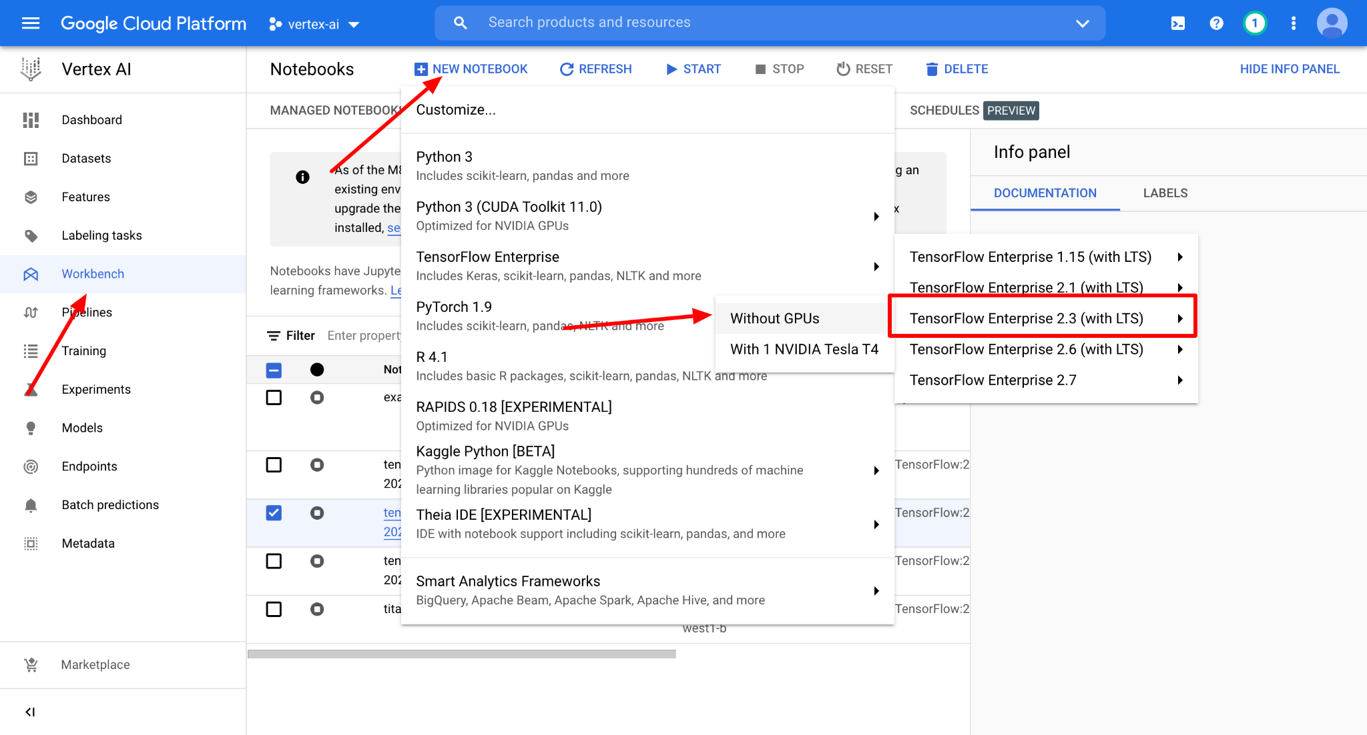

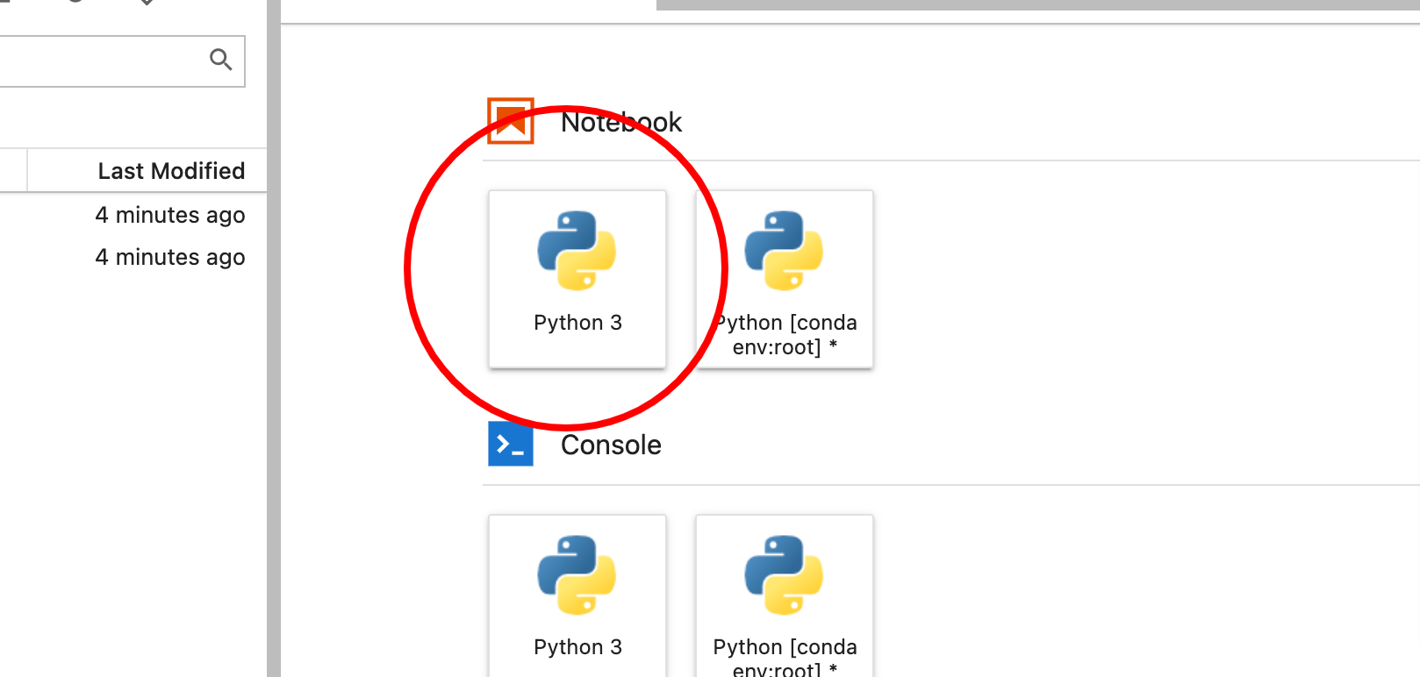

1. Model in the cloud storage

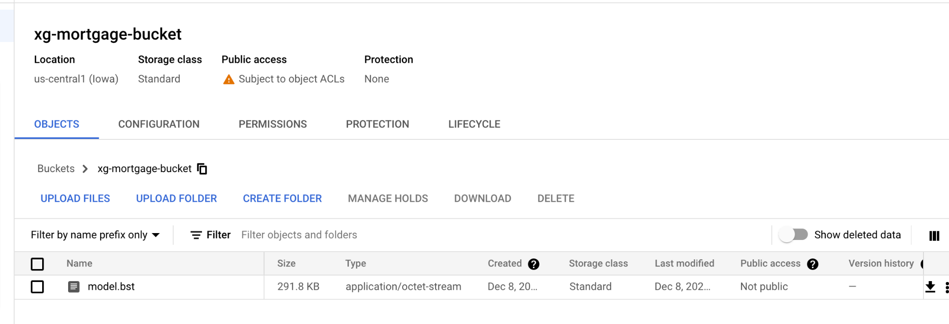

1. Get the model for deployment

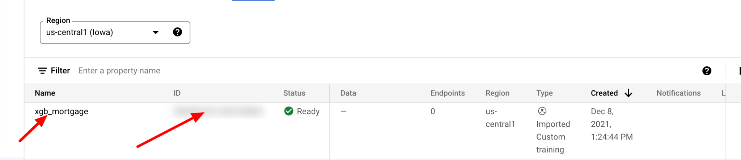

1. Deploying

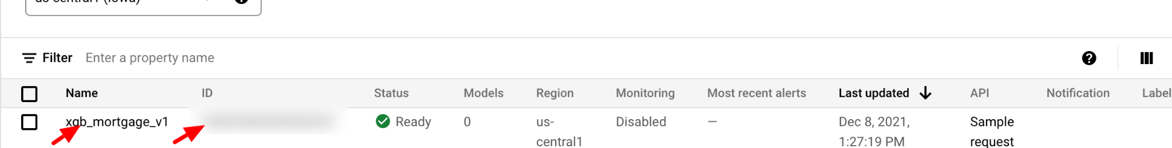

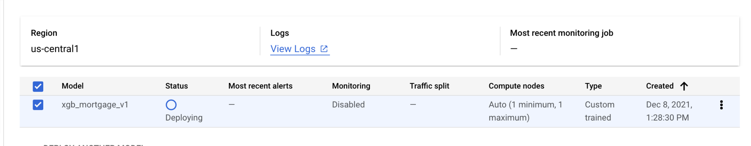

1. Prediction from endpoint

